SMART HOSTEL MANAGEMENT & COMPLAINT AUTOMATION SYSTEM

1. Introduction
The Smart Hostel Management & Complaint Automation System is a web-based platform that helps manage hostel operations and streamline complaint handling. It allows students to report issues digitally while enabling wardens and maintenance staff to track and resolve them efficiently, reducing delays and manual effort.
2. Description
The Smart Hostel Management & Complaint Automation System is a full-stack web application developed using the MERN stack (MongoDB, Express.js, React.js, and Node.js).
The system allows students to register and log in to the platform where they can submit complaints related to hostel facilities.
Examples of complaints include:
• Electricity problems
• Plumbing issues
• Internet connectivity issues
• Room maintenance problems
Once a complaint is submitted, it is stored in the database and assigned a status such as:
• Open
• In Progress
• Resolved
Hostel wardens or administrators can view complaints through a dashboard, assign maintenance staff, and monitor the progress of repairs.

3. Problem Statement
Hostel management in many educational institutions faces several challenges due to manual administrative systems.
Some of the common problems include:
• Difficulty managing student records and hostel data
• Manual complaint reporting leading to delays
• Lack of proper complaint tracking systems
• Poor communication between students and hostel authorities
• Difficulty prioritizing urgent maintenance issues
These problems lead to delayed issue resolution and dissatisfaction among students.
Therefore, a digital platform is required to automate hostel management and complaint handling.

4. Scenario
- Consider a college hostel where students frequently face issues such as electricity failures or plumbing problems.
- A student notices a plumbing problem in their room and logs into the system to submit a complaint.
- The complaint is recorded in the system with a status of Open.
- The hostel warden views the complaint through the dashboard and assigns it to maintenance staff.
- The maintenance staff repair the issue and update the complaint status to Resolved.
- The student can track the status of their complaint through the system.

5. Architecture
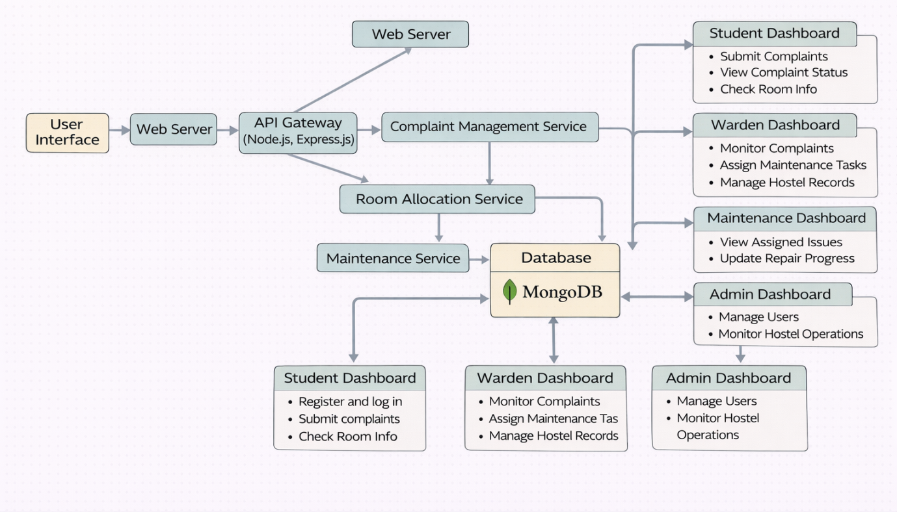
The Smart Hostel Management & Complaint Automation System follows a full-stack architecture using the MERN stack.

Frontend Layer
The frontend layer is developed using React.js.
The frontend allows users to:
• Register and log in
• Submit complaints
• Track complaint status
• View hostel information

Backend Layer
The backend layer is built using Node.js and Express.js.
The backend handles:
• Complaint management
• Room allocation management
• User authentication
• Maintenance task management

Database Layer
The system uses MongoDB as the database.
MongoDB stores the following information:
• Student details
• Hostel room information
• Complaint records
• Maintenance updates

Authentication Layer
The platform uses JWT Authentication.
JWT ensures secure login and role-based access control for:
• Students
• Wardens
• Maintenance staff
• Administrators

6. ER Diagram (Entity Relationship)

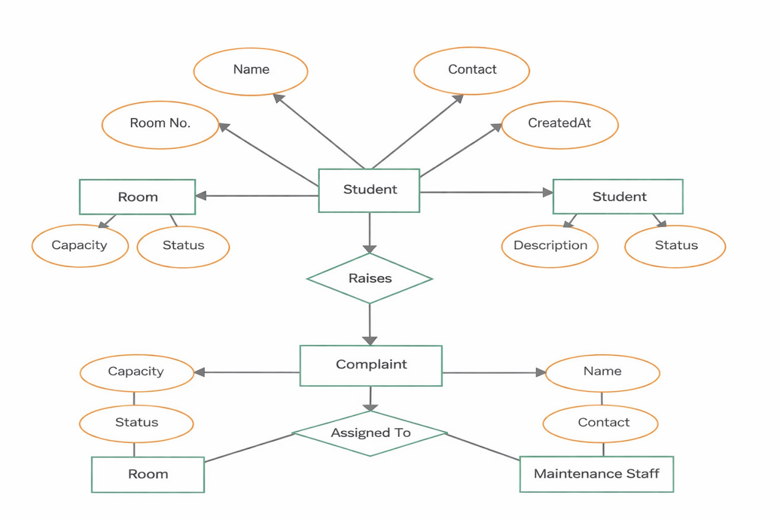
The Smart Hostel Management & Complaint Automation System uses an Entity-Relationship (ER) model to represent how users, students, rooms, complaints, and maintenance records are structured and interconnected.

The main entities in the system are:

1. User Entity
Stores information about all users in the system (Student, Warden, Admin, Maintenance Staff).
Attributes:
• userId
• name
• email
• password
• role
• createdAt
A user can perform different actions based on their role.

2. Student Entity
Stores student-specific hostel information.
Attributes:
• studentId
• name
• roomNumber
• contact
• createdAt
Each student is associated with one room and can raise multiple complaints.

3. Room Entity
Represents hostel room details.
Attributes:
• roomId
• roomNumber
• capacity
• status
• createdAt
A room can accommodate multiple students.

4. Complaint Entity
Stores details of issues raised by students.
Attributes:
• complaintId
• studentId
• roomNumber
• description
• status (Open / In Progress / Resolved)
• createdAt
Each complaint is raised by a student and linked to a room.

5. Maintenance Entity
Tracks maintenance work assigned to staff.
Attributes:
• maintenanceId
• complaintId
• staffId
• status
• updatedAt
Each complaint is assigned to maintenance staff for resolution.

Relationships
• One User can have one role (Student / Warden / Admin / Staff)
• One Room can have multiple Students
• One Student can raise multiple Complaints
• One Complaint belongs to one Student
• One Complaint is assigned to Maintenance
• One Maintenance Staff can handle multiple Complaints

7. Project Flow (System Flow)
The system works through the following steps:
- Students register and create accounts on the platform.
- Users log in securely using JWT authentication.
- Students submit complaints regarding hostel facilities.
- Complaints are recorded and stored in the database.
- Wardens review complaints through the dashboard.
- Maintenance staff are assigned to resolve issues.
- Maintenance staff update the complaint status after repair.

8. User Flow
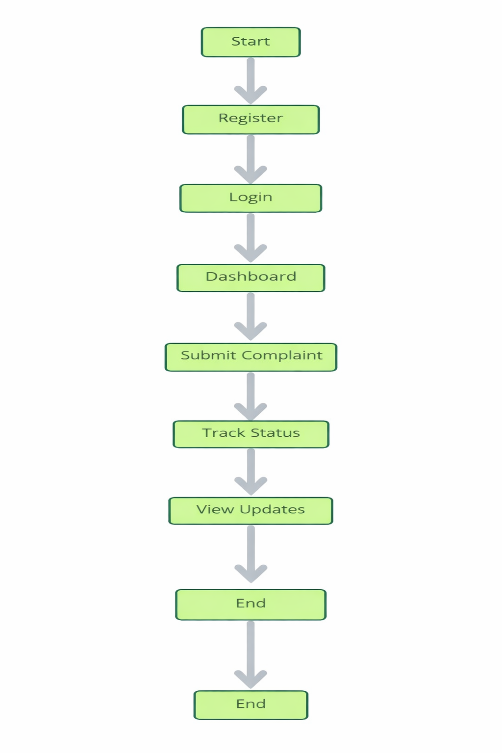

9. Pre-Requisites
To build this project, the following knowledge is required.

Frontend
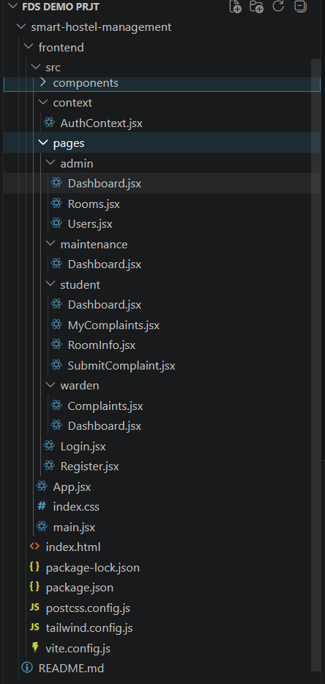
• React Components
• React Hooks
• React Router
• Axios for API calls
• CSS or TailwindCS
Backend
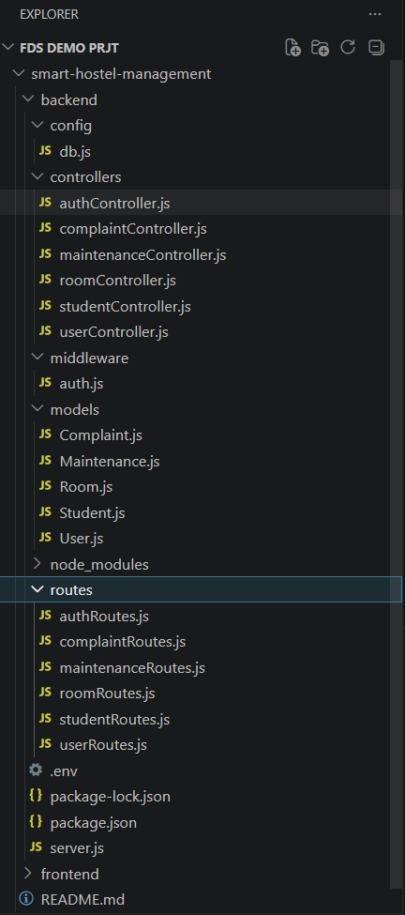

Controllers
● authController.js → Handles authentication logic (login, registration, JWT/session handling for users like admin/students).
● userController.js → Manages general user-related operations (user roles, profile handling, system-level access).
● studentController.js → Handles student-specific operations (student registration, details management, hostel records).
● roomController.js → Manages room allocation and availability (assigning rooms, tracking occupancy, room details).
● complaintController.js → Handles complaint-related logic (students raise complaints, admin reviews and resolves them).
● maintenanceController.js → Manages maintenance requests (issue reporting, status tracking, resolution updates).

db
● config.js → Contains database connection setup (MongoDB configuration, connection initialization, error handling).

middleware
● auth.js → Middleware for authentication and authorization (JWT validation, protected route access control).

models

User
● User.js → Schema/model for user accounts (includes login credentials and role such as admin/student).

Student
● Student.js → Schema/model for storing student details (personal info, hostel-related data).

Room
● Room.js → Schema/model for room details (room number, capacity, occupancy status).

Complaint
● Complaint.js → Schema/model for storing complaints raised by students (issue description, status, resolution).

Maintenance
● Maintenance.js → Schema/model for maintenance requests (problem details, progress status, completion).

routes
● authRoutes.js → Defines API routes for authentication (login, register).
● userRoutes.js → Defines routes for user management and access control.
● studentRoutes.js → Defines routes for student operations (add/view/update student details).
● roomRoutes.js → Defines routes for room allocation and management.
● complaintRoutes.js → Defines routes for complaint handling (raise/view/resolve complaints).
● maintenanceRoutes.js → Defines routes for maintenance requests and tracking.

• Node.js fundamentals
• Express.js routing
• REST API development
• Middleware
• JWT Authentication

Database
• MongoDB document structure
• CRUD operations
• Mongoose ODM
• Schema design

DATABASE DEVELOPMENT:
1. Configure MongoDB:
● Install Mongoose.
In your Node.js project directory, run:
npm install mongoose
● Create database connection.
● Create Schemas & Models.
Create Database connection:
Now, make sure the database is connected before performing any of the actions
through the backend. The connection code looks similar to the one provided below
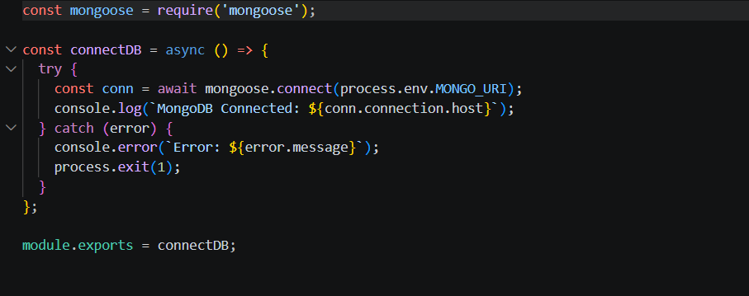

CreateSchemas:
Firstly,configuretheSchemasforMongoDBdatabase,tostorethedatainsucha
pattern.UsethedatafromtheERdiagramstocreatetheschemas.TheSchemasfor
thisapplicationlookaliketotheoneprovidedbelow.

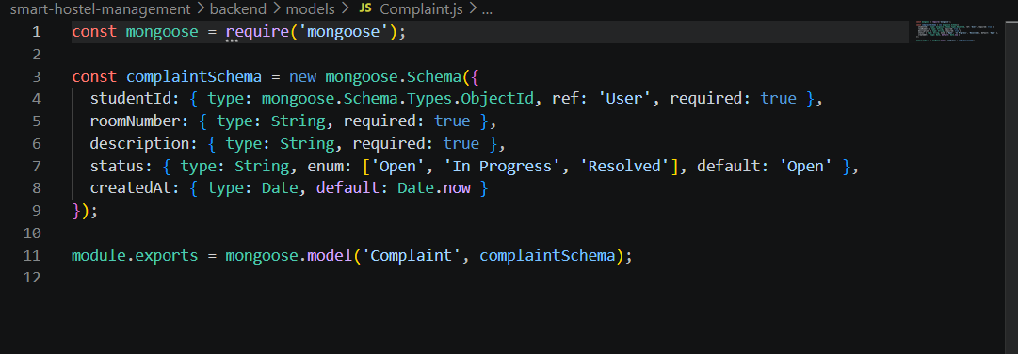

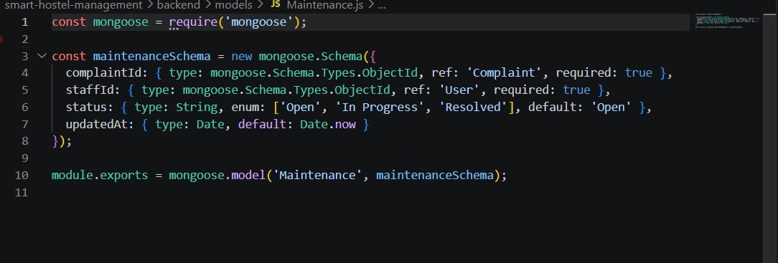
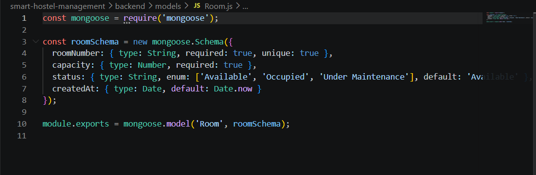

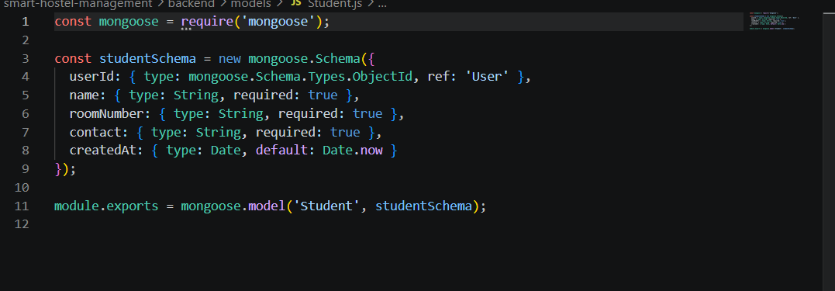

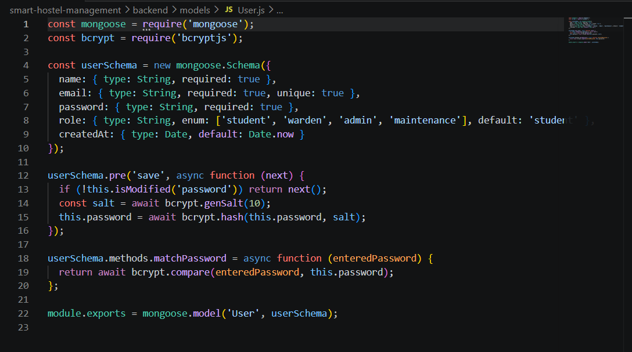

Frontend Modules Description
Admin (src/pages/admin)
● Dashboard.jsx → Admin homepage/dashboard showing overall system data (rooms, users, complaints, etc.).
● Rooms.jsx → Interface for managing rooms (view, assign, track availability).
● Users.jsx → Admin panel to manage all users (students, wardens, etc.).

Student (src/pages/student)
● Dashboard.jsx → Student homepage showing personal info, room status, and updates.
● RoomInfo.jsx → Displays assigned room details (room number, sharing, occupancy).
● MyComplaints.jsx → Shows all complaints raised by the student with status.
● SubmitComplaint.jsx → Form to raise a new complaint.

Warden (src/pages/warden)
● Dashboard.jsx → Warden dashboard for monitoring hostel activities.
● Complaints.jsx → View and manage student complaints (update/resolve).
● Login.jsx → Warden login page.
● Register.jsx → Warden registration page.

Maintenance (src/pages/maintenance)
● Dashboard.jsx → Displays maintenance requests and their status for staff handling repairs.

Components (src/components)
Reusable UI elements used across the application.
● Layout.jsx → Main layout wrapper (handles page structure like sidebar + content).
● Sidebar.jsx → Navigation sidebar for different roles (admin/student/warden).
● StatCard.jsx → Displays key stats (e.g., total rooms, complaints count).
● StatusBadge.jsx → Shows status indicators (pending, resolved, occupied, etc.).

Context (src/context)
● AuthContext.jsx → Manages authentication state across the app (login status, user role, session handling).

Core Files
● App.jsx → Main application component that handles routing between pages.
● main.jsx → Entry point of the React app (renders App component).
● index.css → Global styling for the application.

10. Required Technologies

Frontend

• React.js
• TailwindCSS / Material UI
• Axios

Backend
• Node.js
• Express.js
• JWT Authentication
• Bcrypt

Database
• MongoDB
• Mongoose

Development Tools
• Git
• GitHub
• VS Code
• Postman / Thunder Client
11. Suggested Database Collections

Users
• _id
• name
• email
• password
• role
• createdAt

Students
• _id
• name
• roomNumber
• contact
• createdAt

Rooms
• _id
• roomNumber
• capacity
• status
• createdAt

Complaints
• _id
• studentId
• roomNumber
• description
• status
• createdAt

Maintenance
• _id
• complaintId
• staffId
• status
• updatedAt
12. Key Features

Authentication
• User signup
• User login
• JWT authentication

Complaint Management
• Submit complaints
• Track complaint status
• Update complaint progress

Hostel Management
• Manage student records
• Manage room allocations

Maintenance Tracking
• Assign maintenance tasks
• Track repair progress
13. Optional Advanced Features
• Mobile app integration
• Real-time notifications
• AI-based complaint prioritization
• QR-based room identification
• Maintenance scheduling system

14. Learning Outcomes
By completing this project, developers will learn:
• Full-stack MERN application development
• Complaint management system design
• REST API development
• Database schema design
• Dashboard development
• Scalable web application architecture
- OUTPUTS
LOGIN PAGE:
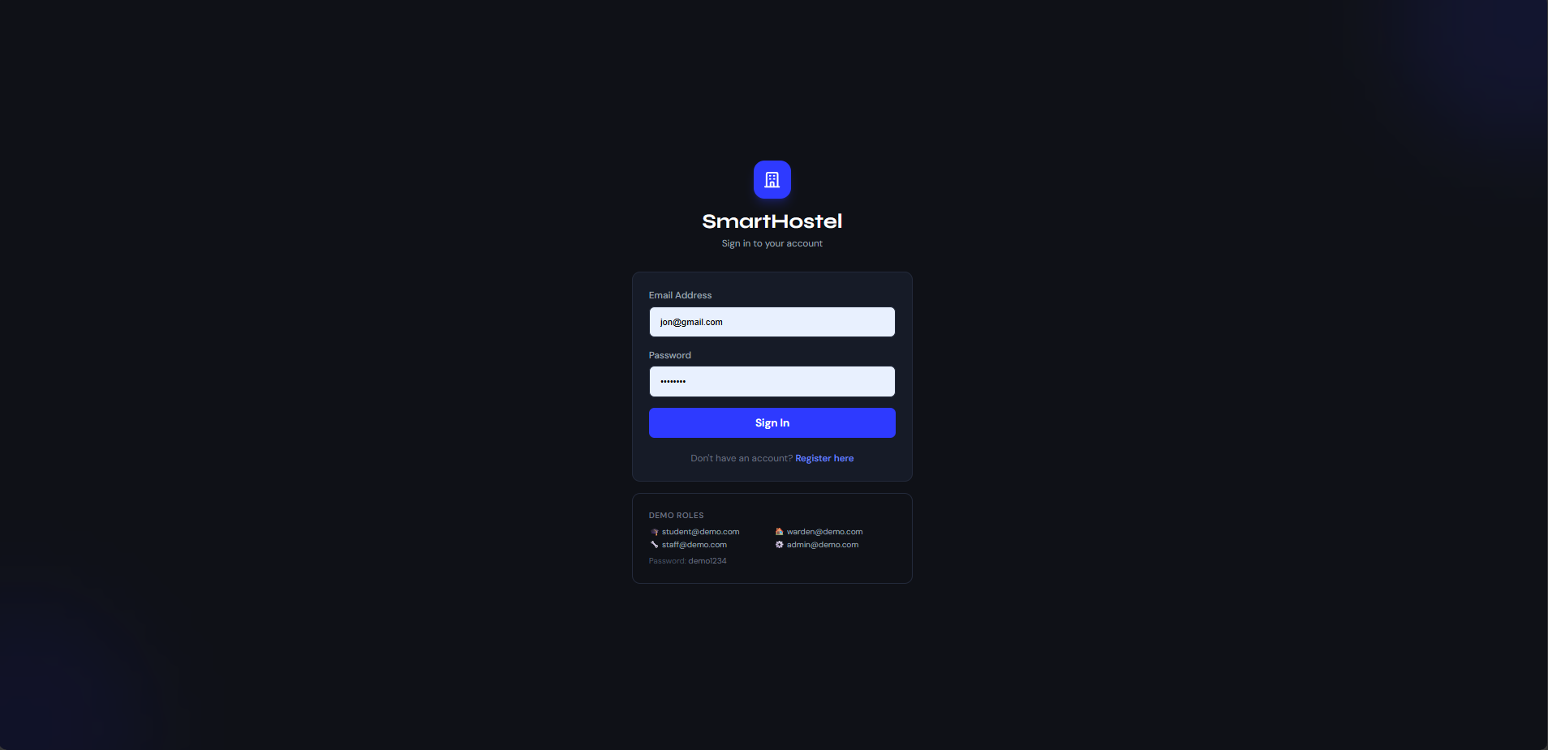

Warden dash board:
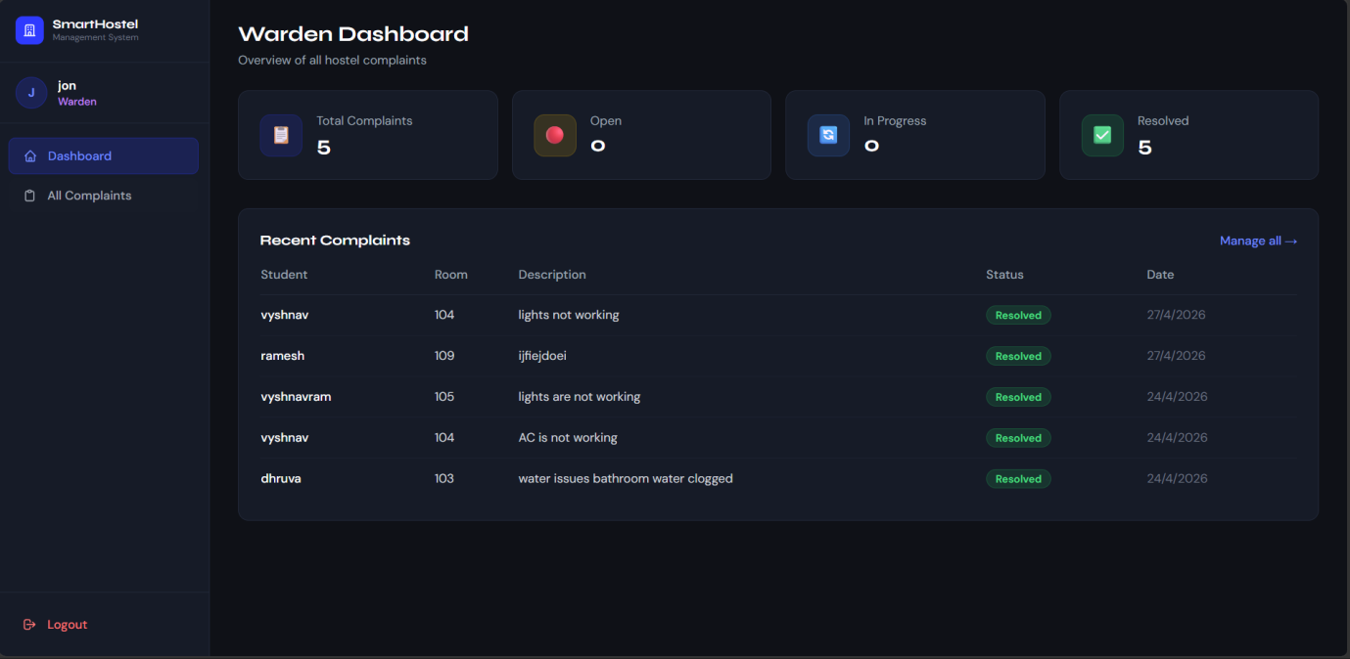
\

Warden complaints checking modal:

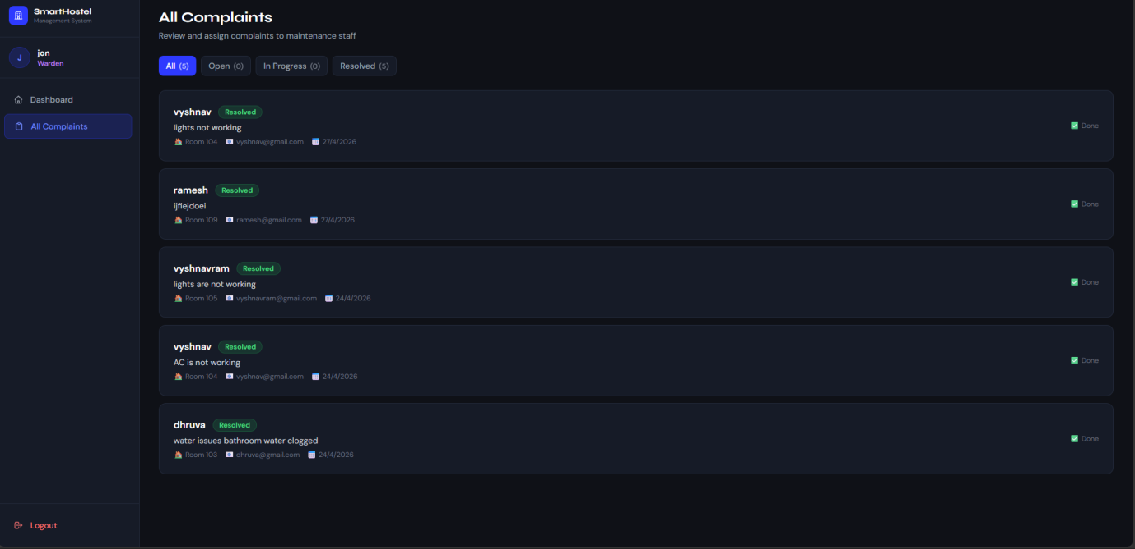

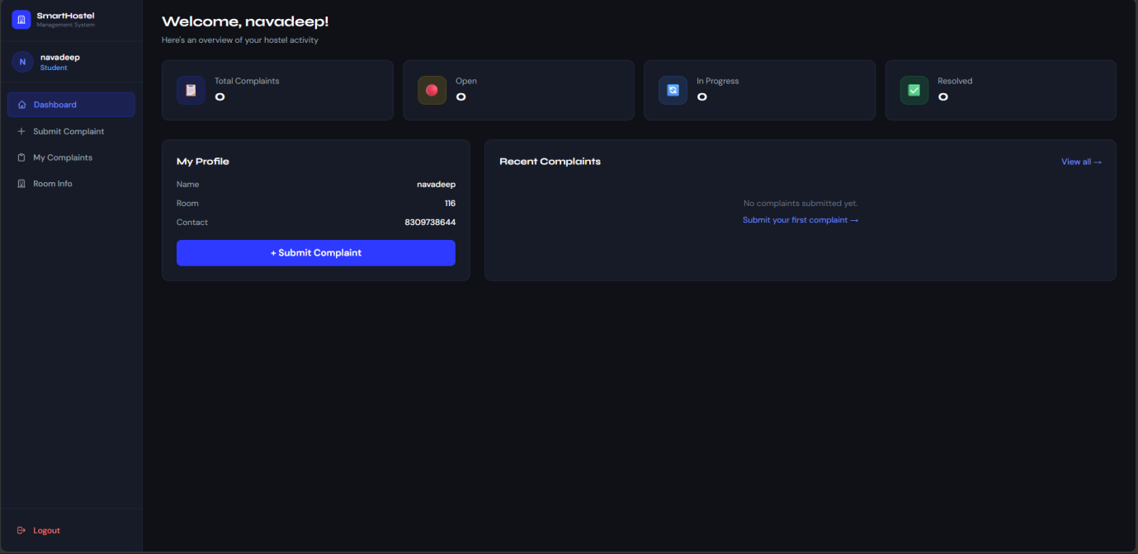

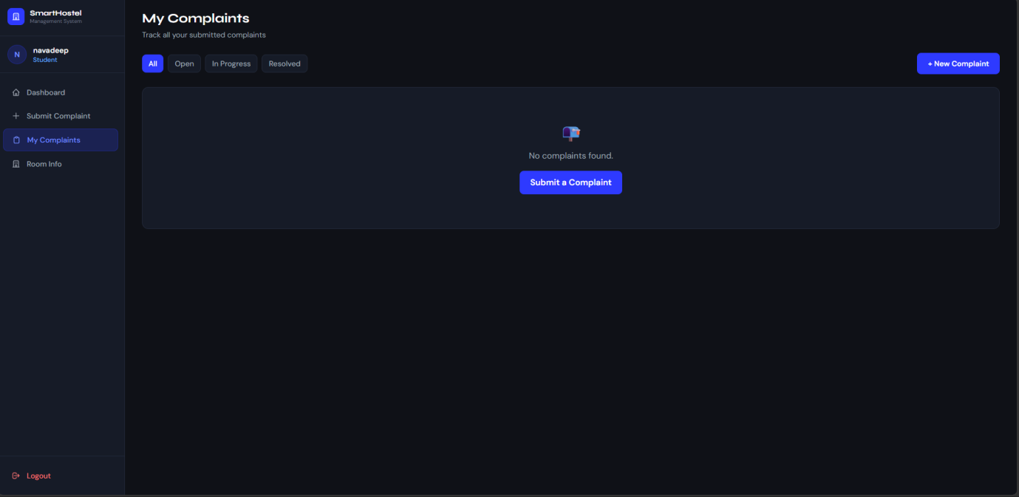

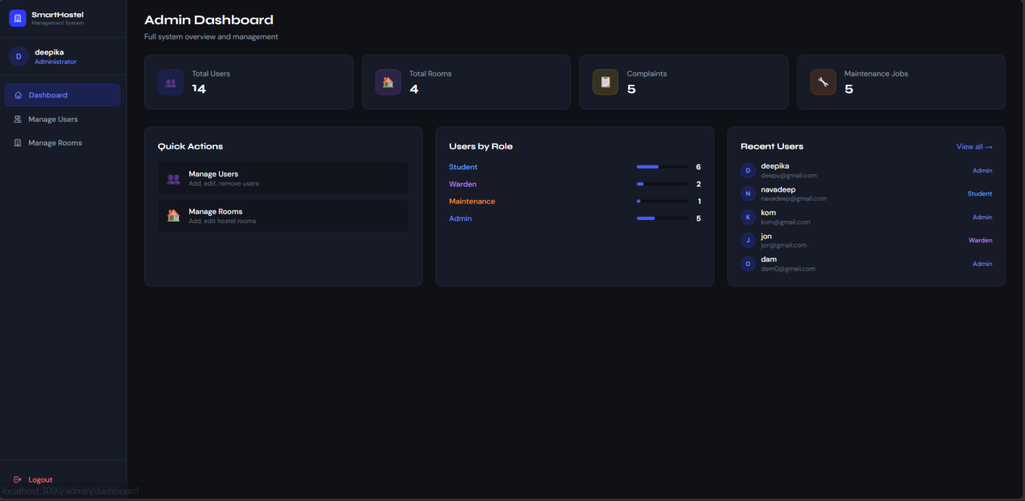

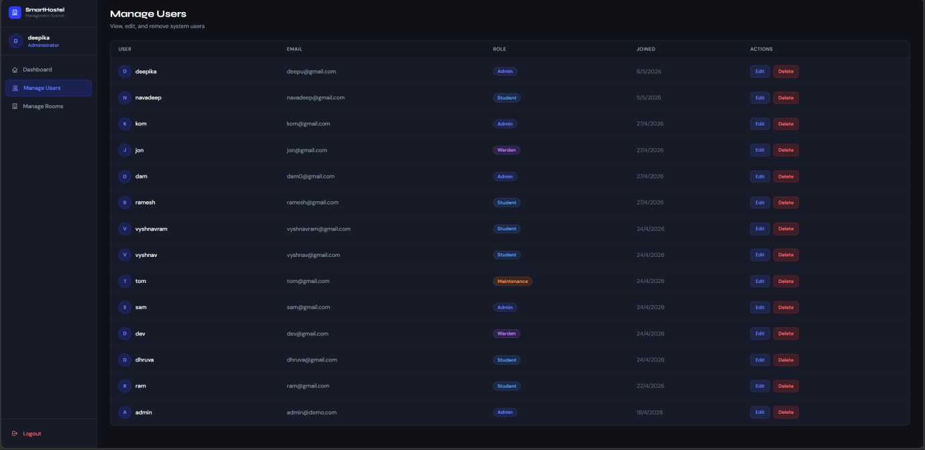

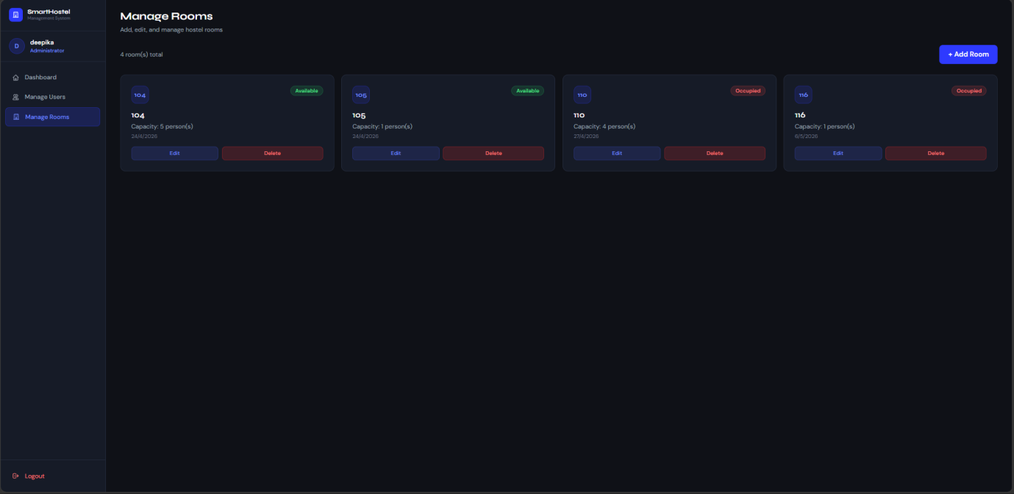

Video drive links:
Code explanation link:
https://drive.google.com/file/d/1El3sNJuoF3Q55yhtrruAC41cbeRkr8fs/view?usp=drive_link

https://drive.google.com/file/d/1El3sNJuoF3Q55yhtrruAC41cbeRkr8fs/view?usp=drive_link

web page explanantion link:
https://drive.google.com/file/d/1YZrBxmavEcx8euMfN8-cXrJORZxB6w3Q/view?usp=drive_link

